**Name-Surname :** Doğukan Berat KARATAŞ

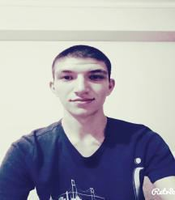

**Address :** Mehmet Ali Altun Caddesi, Kazım Orbay Mahallesi,

339. Sokak, erdoğan Apartmanı, No:18/8,

Akdere/Mamak/ANKARA

**Telephone :** 0555 650 5863

**E-Mail :** [007berat.karatas@gmail.com](mailto:007berat.karatas@gmail.com)

PERSONAL INFORMATION

**Date of Birth :** 01/01/1989

**Nationality :** Turkish

**Sex :** Male

Driving License : B

EDUCATION

2015 - 2020 : Hacettepe University - Computer Engineering, Ankara

2011 - 2015 : Çağrıbey Anatolian High School, Ankara

LANGUAGE SKILLS

**English :** Reading - Advanced, Writing - Intermediate, Speaking - Beginner

**Korean Language :** Reading - Intermediate, Writing - Beginner, Speaking - Beginner

**Japanese :** Reading - Beginner, Writing - Beginner, Speaking - X

COMPUTER SKILLS

**Word, Excel, PowerPoint :** Intermediate

**C Programming Language :** Beginner

**JAVA :** Intermediate

**PYTHON :** Intermediate

HOBIES & SPORT ACTIVITY

I like reading a book, listening to music and drawing a picture. I was a athlete when I was 14 years old.